Title of the Paper (style Title: font Calibri; size 14pt; bold)

  - Name Surname¹*, Name Surname² (style Subtitle: font Calibri, size 12pt, bold)
¹Institution, faculty, department, city, state (of first author) (Style Institutions, font Calibri, size 11pt)
²Institution, faculty, department, city, state (of second author)

Abstract: Insert a short English annotation (maximum 10 lines) providing a brief description of the topic of the paper (style Intro, font Calibri, size 10pt, justified)
Keywords: State a maximum of 5 key words separated by comma (style Intro, font Calibri, size 10pt, justified)
JEL classification: Insert up to 3 JEL codes, please follow the guide at https://www.aeaweb.org/jel/guide/jel.php (style Intro, font Calibri, size 10pt, justified)
Grant affiliation: Can be deleted in a case of no affiliation (style Intro, font Calibri, size 10pt, justified)

Introduction (style H1, font Calibri, size 12pt, bold)
Text of the contribution (Style Normal, font Calibri, size 11pt, justified). Use the MS Word text editor 2007 or later (2010, 2013, 2016) to write the paper. Please follow the specified styles and formatting of sections of the article (e.g. title, heading, chapters, references, etc.).
Please note that the paper must not exceed 7 pages at maximum including text, figures and tables. Papers must be written in English Language. Please do not number the pages. Contributions with more than 7 pages will be not published!
Use APA7 citation style for both in-text citations and well as a reference list. For every in-text citation there must be a full citation in the reference list and vice versa (see https://apastyle.apa.org/style-grammar-guidelines/references/examples). Footnotes are not allowed (except for the specification of the corresponding author). Papers without references will be not published!

Tables
Tables used in the contribution should be centered, numbered continuously and cited in the text (… as can be seen in Table 1…). Caption of the table should be above the table and be self-explanatory. Text in the table should use style Table (font Calibri, size 11pt)
Table 1: Table caption (style Caption, font Calibri, size 11pt, bold)
Year | 2010 | 2011 | 2012 | 2013 | 2014
Points | 35 | 42 | 25 | 47 | 23

Figures
Figures used in the contribution should be centered, numbered continuously and cited in the text (… as can be seen in Figure 1…). Do not provide figures with insufficient resolution. Caption of the figure should be under the figure and should be self-explanatory.
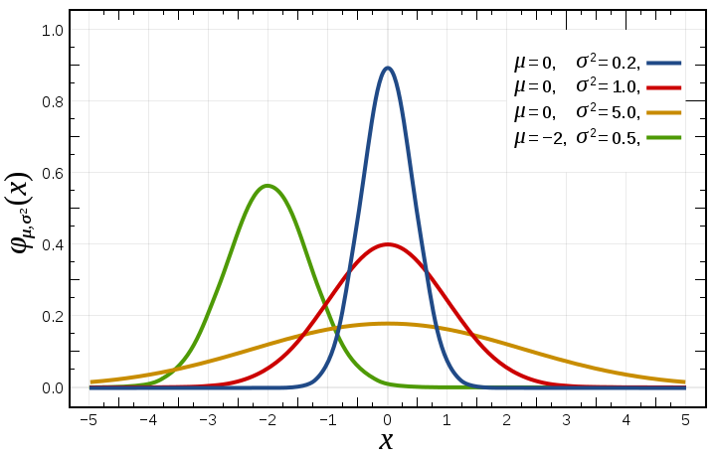
Figure 1: Figure caption (style Caption, font Calibri, size 11pt, bold)

Mathematical formulas
Mathematical formulas displayed in separate lines should be centered. If you need to refer to the formula in the text, please use “Invisible table” trick as is shown below:
 | $$f\left(x\right)=\frac{1}{σ\sqrt{2π}}e^{-\frac{{\left(x-μ\right)}^{2}}{2σ^{2}}}$$ | (1)

Chapter and subchapter
Text of the chapter.

Subchapter (style H2, font Calibri, size 12pt, bold)
Text of the first-level subchapter.

Subchapter (style H2, font Calibri, size 12pt, bold)
Text of the second-level subchapter.

Conclusion (style H1, font Calibri, size 12pt, bold)
Text of the conclusion.

References (style References, font Calibri, size 12pt, bold, unnumbered)
Style Normal, font Calibri, size 11pt, justified, space between two references: 5pt, align left, line spacing single. References need to be written using APA7 citation style, DOI as a hyperlink in blue. Each publication in the references must be cited in the text of the paper. The contribution using different citation style will be not published!
Kidder, T. (1981). The soul of a new machine. Little, Brown & Company.
Gibbs, J. T., & Huang, L. N. (Eds.). (2001). Children of color: Psychological interventions with culturally diverse youth. Jossey-Bass.
Labajo, J. (2003). Body and voice: The construction of gender in flamenco. In T. Magrini (Ed.), Music and gender: Perspectives from the Mediterranean (pp. 67–86). University of Chicago Press.
Van Vugt, M., Hogan, R., & Kaiser, R. B. (2008). Leadership, followership, and evolution: Some lessons from the past. American Psychologist, 63(3), 182–196. https://doi.org/10.1037/0003-066X.63.3.182
Deming, D., & Dynarski, S. (2008). The lengthening of childhood (NBER Working Paper 14124). Cambridge, MA: National Bureau of Economic Research. Retrieved July 21, 2008, from http://www.nber.org/papers/w14124.
For more see: https://apastyle.apa.org/style-grammar-guidelines/references/examples

* Corresponding author’s email: “Place corresponding author’s email here”

